**Problem 1-**

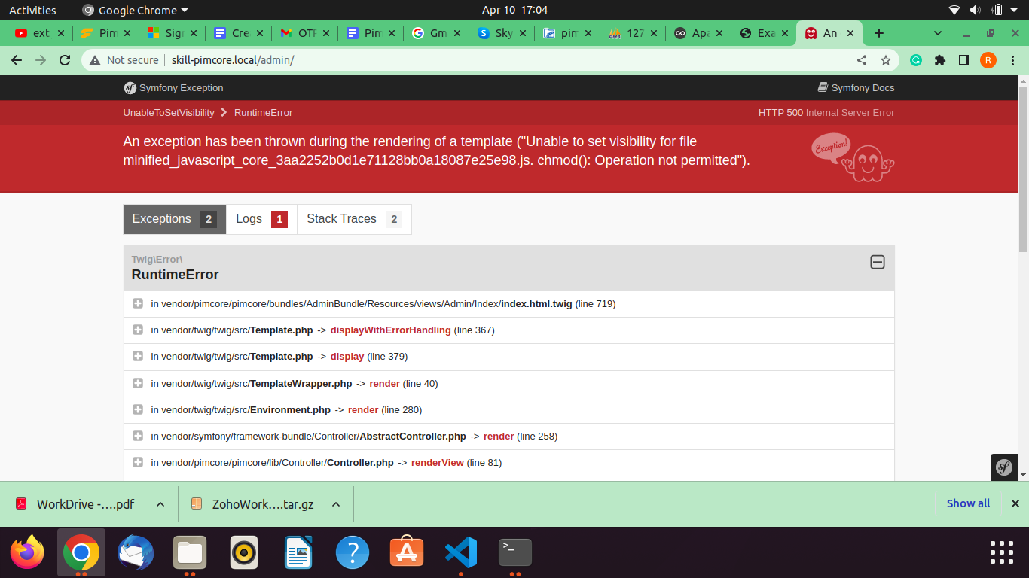

**Solution ::**

1- Remove vendor folder from project

2- Go to the project folder and run cmd **composer update**

**Problem 2-**

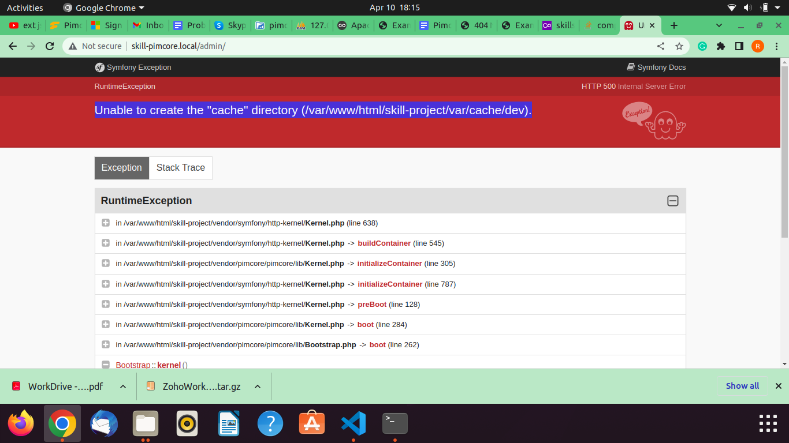

**Solution :: run these commands**

bin/console

bin/console assets:install

bin/console c:c